* Manages performance and behavior of 20-25 Amazon Seller onsite associates through
* Effective 1:1 meetings, coaching, and mentor ship and would operate from HYD15.
* Implements performance goals, monitors and evaluates against pre-set goals implementing action plans to resolve performance barriers as needed.

Reviews and analyzes performance metrics to identify areas of opportunity that will drive performance improvement.

* Ensures that associates have a clear understanding of the performance and behavior criteria and how it impacts site performance and the overall seller experience.
* Partners with workforce management to execute daily staffing plans, identifies and reports significant volume and capacity changes, making just-in-time adjustments to ensure staffing requirements are met to achieve service levels goals.
* Manages schedules, monitors adherence, time-off planning, and attendance in partnership with Workforce Management.
* Participates in daily Gemba/ Kaizen events to identify and implement process improvement change initiatives.
* Conducts seller interaction audits and provide coaching to improve performance.
* Maintains a positive and professional demeanor, always portraying the company in a positive light and **effectively managing sensitive issues**
* Demonstrates excellent time-management skills and the ability to work independently while using departmental resources, policies and procedures.
* Liaise with other departments such as Customer Service, Merchant Investigations, or Payments teams as required to resolve Seller's issues and questions

**Definition and Indicators**

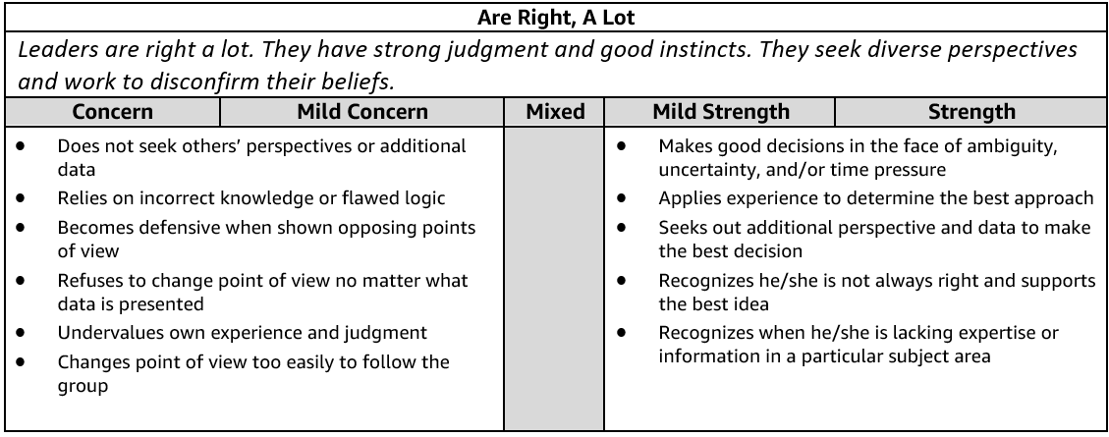

1. **Tell me about a time when you didn't have enough data to make the right decision.** What did you do? What path did you take? Did the decision turn out to be the correct one?

**Answer)** Cape Town Connections – When I was approached by my site leader to help the Capetown site – (pick that example)

**I had to forecast for a CONTACTOR with no or minimal purchasing history. of just one quarter.**

**Took the opinion of peers, team and the product manager who showed me the various areas or specs where this RELAY could be used and aligned with Project Engineers to figure out required POWER RATING, the application of this contactor FFs / Vendors to provide the last quarter sales for such similar RELAYs based on which I made a projection of 15% which turned out to be about 2% more. Although I was not perfect but the 2% was within the threshold limits.**

1. **Tell me about a strategic decision you had to make without clear data or benchmarks.** How did you make your final decision? What alternatives did you consider? What were the tradeoffs of each? How did you mitigate risk?

**Answer) VCC Connections , Alternative –** VCC All hands explored chime as an option **,** calling people to office **,** broad cast and chose broadcast as a better option. **Tradeoff-** Challenges faced for each option**. Mitigate Risk –** There was no real risk involved , even when we called people to office we ensured seats are available , broadcast – we ensured videos are collated on time.

……..Similar to above

1. **Tell me about a time when you made a difficult decision with input from many different sources (customers, stakeholders, partner teams, etc.).** What was the situation and how did you arrive at your decision? Did the decision turn out to be the correct one? Why or why not?

**Answer) ABQ Mechanism –** Based on WW quality data, Based on ATM inputs from supervisors , based on IND Level mechanism , based on inputs from OM’s --- Difficult decision to go via CAG route for Sups (Talk about ABQ example)

To satisfy a customer request with very very low profit margins beyond which the project would be break-even or without making any money for ABB.

I wanted to satisfy the customer request so I had to partner with below teams….

Pricing Team 🡪 for further discounts which they couldn’t

Product Mgmt 🡪 for alternate items / customize

Shipping agencies 🡪 to negotiate on the already agreed blanket prices

Peers / Team members 🡪 to suggest alternatives

Project design team 🡪 to revisit the project design from different viewpoints.

Sales 🡪 bidding

1. **We don't always make the right decision all the time. Tell me about a time when you made a bad decision**. What was the impact of that decision? What did you learn? How have you applied what you learned?

**Answer ) Flex learn –** Virtual hiring and virtual training

Thin margin order to minimize the material cost I looked at several avenues and was lured by the 8% special offer provided by the supplier but the shipping terms were **SEA FREIGHT (bad decision)**

**Teamed up with other business units listed down orders in pipeline (unconfirmed orders) to come in with probability of 60 to 70%, looked for same materials in such projects and took the RISK of placing order against such unconfirmed projects by the normal AIR FREIGHT 🡪 on arrival I diverted this to the above low margin project and realigned the SEA FREIGHT shipment to this unconfirmed orders.**

**SUCCESSFULLY delivered the project on time**

**BIG Success in disguise was that due to the SEA FREIGHT shipment costing less, the 60-70% probable projects got confirmed due to revise in the bid by the sales dept.**

1. **We don't always make the right judgment all the time. Tell me about a time when you made an error in judgment**. What was the impact? What did you learn? How have you applied what you learned?

….Similar to above…

1. **Tell me about a time when you discovered that your idea was not the best course of action.** What was your idea? Why wasn't your idea the best course of action? How did you find out it was not the correct path? What was the best course of action? Who provided it? What did you learn from the experience?

**Flex Learn**

….Similar to above…

Best course of action was to order by AIR not to budge into the 8% discount, I realized it myself…

1. **Describe a time when you brought different perspectives together to solve a problem.** What types of different perspectives were represented? How did you seek out different points of view? What was the outcome? Where there any key learnings from this experience? Knowing what you know now, would you have done anything different?

**Capetown Connections**

Pricing Team 🡪 for further discounts which they couldn’t

Product Mgmt 🡪 for alternate items / customize

Shipping agencies 🡪 to negotiate on the already agreed blanket prices

Peers / Team members 🡪 to suggest alternatives

Project design team 🡪 to revisit the project design from different viewpoints.

Sales 🡪 bidding

**Definition and Indicators**

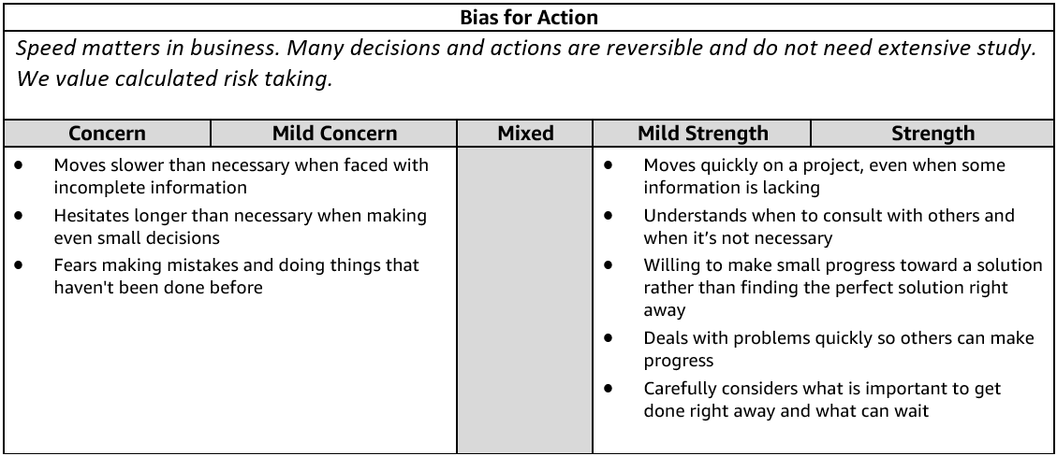

1. **Give me an example of a calculated risk that you have taken where speed was critical.** What was the situation and how did you handle it?  What steps did you take to mitigate the risk?  What was the outcome? Knowing what you know now, would you have done anything differently?

**IQM Story …** Quarter over quarter we raised the bar so we wouldn’t have done anything differently as the entire activity really ran well.

Business Unit was in a hurry to start ordering the materials for his critical project

Teamed up with him to take his customer on the call and had them list down the requirements and divided them into **3** groups from the cost standpoint.

Most Expensive /lesser / not expensive and started ordering the least expensive first ….**As the project progressed I had more clarity of the requirement.**

Thus minimized the risk…….

**OR**

URGENT requirement of two units which were damaged while assembling in the assembly line, it was important to ship them in 5 days…rather I decided to approach our distributor to sell it to us which was lesser in cost as compared to shipping it from ABB Italy.

1. **Tell me about a time when you worked against tight deadlines and didn't have time to consider all options before making a decision.** How much time did you have? What approach did you take? What did you learn from the situation?

CAPETOWN – Within 2 weeks was asked to travel and improve connections for a different region

I was confident that as the SEC govt sector project progressed, I would have more clarity on the required specs of the CAPACITOR BANK / Enclosures

I reviewd the history of purchase of the capacitor for SEC govt sector and proceeded to order

1. **Describe a situation where you made an important business decision without consulting your manager.** What was the situation and how did it turn out? Would you have done anything differently?

Used the GSM offer for RTCC project in order not to lose the RTCC order quantities had exhausted. Later on worked with my manager to request his senior mgmt to increase the quantities of the GSM offer items citing genuine reasons of losing out on a customer if not fulfilled.

**Post Peak Party – I** had a holistic budget to run the post peak party as there was a tight deadlines or the venue would hve been released by the venue managers so we went with JRC as they were giving us best cost and food price with a large parking space (200 cars) compare to the other venue which was there for N-convention or Novotel. Later I aligned everyone towards the venue as it was cost saving and was more grand compare to all our past venues in all aspects.

1. **Tell me about a time when you had to gather information and respond immediately to a situation.** What was the outcome? Would you have done anything differently?

**Capetown**

I was confident that as the SEC govt sector project progressed, I would have more clarity on the required specs of the CAPACITOR BANK / Enclosures

I reviewd the history of purchase of the capacitor for SEC govt sector and proceeded to order

1. **Give me an example of when you had to make an important decision and had to decide between moving forward or gathering more information.** What did you do? What was the outcome? What information is necessary for you to have before acting?

**IQM**

**Several instances where I decided to move forward**

**🡪 due to time constraint from the deadlines standpoint.**

* **Due to past experience of similar such requirement EXPERIENCE**

1. **Tell me about a time when you saw an issue that would impact your team and took a proactive approach to solve it.  What was the issue? What did you do and what was the outcome? What did you learn from this situation?**

**When 2017 VAT was to be introduced in SAUDI ARABIA, even before the company came out wih the training modules of PO creation with VAT which would have an impact on the turn around time for PO processing, I anticipated quickly and conducted several offline sessions with my team through the SAP screens with VAT as I had worked in other geographies where VAT was in place for long.**

1. **Tell me about a time when you felt your team was not moving to action quickly enough.** What was the situation? What did you do? What was the outcome? Would you have done anything differently? (Manager)

IQM was not moving quickly …team was not meeting the goal from 3 consecutive months..

When I noticed a decline in no of issues resolved and closed by 20% in the past one month vis a vis the previous months I reviewed the pending issues in the queue. I worked out a plan and segregated the issues and divided them in the team and called for a very short 15 minute post lunch follow up meeting to resolve then close the issues, I asked one taem member to chair this short call and made them own it…..

There were some issue that were related to the bugs not fixed after the implementation….recurring issue…I sought enhancemanet project request and put my offshore team to close it in 2 weeks.

1. **Tell me about a time when you were able to remove a serious roadblock/barrier preventing your team from making progress. What was the barrier? How were you able to remove it?  What was the outcome? Knowing what you know now, would you have done anything differently?  (Manager)**

**The PO and OA were automated thru the IDOC process between our FFs and our SAP system….every week some batch job failed due to some missing filed in the PO or OA …..team had to manually update the OAs**

**One supervisor was handling multiple skills so it was reduced to minimal skills n relate to IQM**

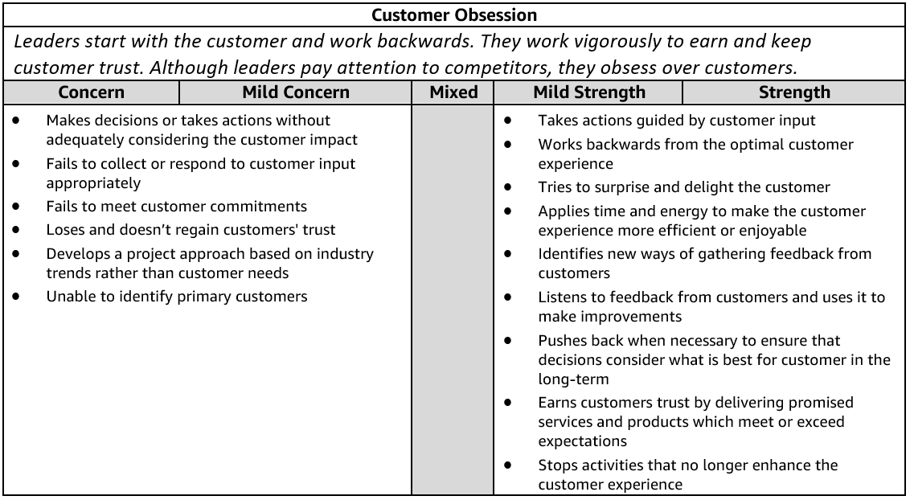

**Customer Obsession - Suggested Behavioral Interview Questions**Please choose 2-3 questions below for your interview.

1. **Describe a difficult interaction you had with a customer.** How did you deal with it? What was the outcome? How would you handle it differently?

**GE example of a old customer escalation as the customer wanted to talk with Home Depot customer service manager**—Customer missed the payments for 5 months ….. Customer moved as she lost her husband ….moved to a diff place as she couldn’t afford the old place ….n she was a joint account holder on the account …….She was in depression and had no source of income and now she caught up on her job and life after 5 months… n wanted to get stable in her life ….Went on the call and patiently heard her side of the story and basis the policy …….on humanitarian grounds went ahead Clearing the delinquency and updating the credit bureques and assuring the customer of good standing .all 3 prominent credit bureaus of get updated with this action and her credit rating gets into good standing….

To satisfy a customer request who would cancel the order if his requet was not met. It was so low priced that beyond which the project would be break-even or without making any money for ABB.

I wanted to satisfy the customer request so I had to partner with below teams….

Pricing Team 🡪 for further discounts which they couldn’t

Product Mgmt 🡪 for alternate items / customize

Shipping agencies 🡪 to negotiate on the already agreed blanket prices

Peers / Team members 🡪 to suggest alternatives

Project design team 🡪 to revisit the project design from different viewpoints.

Sales 🡪 bidding

Myself, the product mgmt team

the project design team and

Quality team

redid the design in line with the customer’s approval and designed an alternate circuit to **serve** the **same** **purpose** by which we could save MCBs / Contactors and thereby without affecting our profit margin or not letting the project go into 0000 marging at the same time without affecting the quality of the panel,

so customer was satisfied and project was not in loss

1. **Tell me about a time when you went above and beyond for a customer**. Why did you do it? How did the customer respond? What was the outcome?

**AHS Spanish Call – Approved process was to ask the Spanish customer to call back and see if they can get connected to the AHS Spanish speaking associate so as per the process this was the right thing to do but was not helping the customer as this was time consuming efforts…**

**I believe in not just delivering materials on time but always look at scope for offering product plus to the customer**

**I closely associate with Prod Managers of different products Capacitors, Relays, contactors, terminal blocks, breakers, switches and get updates from them on the tech specs of the materials that I purchase.**

**A BU manager requested for MCBs and Terminal Blocks**.

**One of our BU had placed PR to buy relays for his panel he was assembling in the factory. He wanted 20 relays and his panel that had 40 capacitors breakers terminal blocks and other stuff.**

**I aligned with the Prod Manager for MCBs Relays and he told me of an MCBs that was more robust, low on power consumption by 12% and provided 8% more surge protection (ABB relay that could operate 12 capacitors at a time).**

**ACTION**

**Because of different time zones, I arranged a concall with the below**

**product manager,**

**the BU,**

**quality team and**

**the customer**

**and explained the ability of MCBS / relay that had the following ADDITIONAL features**

**Operate 12 capacitors at a time.**

**Improved surge protection by 8%**

**12% lower on power consumption.**

**Almost at the same price as the one to be ordered**

**Post the call we arranged an internal call with quality and customer and got the quality approval.**

**Result**

**BU was overwhelmed with the benefits he was going to achiever by the project. He thanked me for the great offer I provided to him without he asking for anything.**

1. **Give me an example of when you were able to anticipate a customer need with a solution/product they didn't know they needed/wanted yet**. How did you know they needed this? How did they respond?

**Answer** ---AHS Spanish Caller customer never asked for a separate queue but we proactively did this to help the customer

HCLA my routine review of the history of issues resolved, there were about 2 items configuration in Mat Master tab PACKING UNITS AND BATCH SIZE that were repeatedly requested by the SENIOR MANAGERS for their material planning meetings.

I had my team develop a report to capture the two items in the MM basic data tab PACKING UNIT AND BATCH SIZE in addition to the two fields I had the ATP quantities included in the report which was not requested by them and had it sent via a link to them through the shared folder for the managers.

They were delighted that they got something they didn’t ask for but helped them plan upfront, before they used to check the ATP quantities manually.

1. **Give me an example of a time when you asked for customer feedback**. How did you use that feedback to drive innovation or improvement? How did the customer respond?

**Answer**--- 1) GE - Mervyns Client had huge Payment queue as the customer was not educated about the payment options and this was realized while listening to quality calls to do a dip stick to understand the quality of calls and customer feedback on real time basis. Basis the call volume and customer’e real time feedback on calls and associate round table we came up with the plan to educate the customer about various payment options available for the mervyns private label credit cards.. Customer was only aware about store payment…..they had no clue about online payment as this was realized by collating real time feedback and survey rolled out at the time of payment by the store associates and even by customer reps..

**So we started publishing a message “ make your payment online now at mervyns**.com” on every single billing statement. Also at the bill desk in the store we started banners of various payment options available for mervyns private label credit cards from store payments , online payments and paypal payments.

**Example from AtoZ** – Employees are also internal customer and trawler survey was rolled out to seek feedback from team supervisors on INGENII feedback mechanisms. So we have come up with an internal mechanisms and created sharepoints to capture these feedbacks by TM’s on monthly basis and asked OM’s to do dipstick once in a month on any one form and capture the same on a different sharepoint. This is in pilot phase

HCLs 360 degree feedback mechanism captures the feed back of every individual associated with you includeing customers to subordinates.

I study every individual’s feedback and in my next correspondence or meeting with him I consciously try to inculcate the areas of improvement he expects from me. Helped me tremendously improve myself personally and professionaly.

1. **Tell me about a time when you evaluated the customer experience of your product or service**. What did you do? What was the result?

Walk store mechanism

ABB customer feedback portal captures feedback of all the vendors and customers which has a direct bearing on our performance appraisals and bonus calculations. REGARDLESS of this tool, bcos of my exposure to HCLs 360 degree, it was inculcated in me to always get good positive feedback from my stakeholders.

1. **Tell me about a time when a customer came to you for something that wouldn't actually address their need.**How did you approach the situation? What was the result?

BU manager was asking for a monthly report indicating the Price List of Terminal Blocks from the FF ABB France. On deep diving as to why he wanted it I found that he wanted to add the Del Lead Time to the price to quote for a bid for his special upcoming project. But I pulled up an already existing report which is up to date regularly with prices which already had the DLTime built in. although he was using this report but for looking the delivery lead time from the FF. he had not didn’t look at this column before.

1. **Sometimes customers make unreasonable requests.** **Tell me about a time when you've had to push back or say no to a customer request.** What did you say or do in response to that request?

**Answer** ---AHS Spanish Caller

Customer wanted to place a RUSH order for 5 capacitors which he had missed out in his BOM calculation……

He was ready to have the express shipping charged to his BU account,

I offered him a solution where in he could get his material but also at a lesser cost….

I checked with our local ABB authorized distributor who could sell it to us back without taking a hit on his margin, he readily agreed and I got the matrial at the distributor price thus saving on the express shipping charges.

Persuade

1. **Tell me about a time when you had to balance the needs of the customer with the needs of the business.** What did you do? What was the result?

Gating upskill or AHS Spanish queue though it will marginally impact our transfer rate we still created a separate Spanish queue

**THIS THIN line is addressed best by identifying the needs of the customer and to adopt the organization towards delivering those needs in the MOST effective and efficient manner TO ACHIEVE THE ORGANIZATIONAL GOALS.**

**I am here becos of the CUSTOMER and I am hired by MY COMPANY becos I have to serve them BOTH CUSTOMER and MY COMPANY.**

WITHOUT COMPROMISING ON QUALITY Several times I had to convince my Product Managers for alternate cost effective materials

WITHOUT COMPROMISING ON QUALITY Several times I had to look at alternate means of shipping to save Company’s cost to meet the customers need.

WITHOUT COMPROMISING ON QUALITY Sevverl time I had to reach out SENIOR MGMT through the help of my boss I for additional discounts

WITHOUT COMPROMISING ON QUALITY SEVERAL times I had to partner with design team to look at alternative ways to meet the Customer’s need.

How I could tweak myself and my company within threshold limits BUT to have the CUSTOMER’s need fulfilled.

1. **Give me an example of a change you implemented in your current team or organization to meet the needs of your customers.** What has been the result? (Manager)

**Answer** ---AHS Spanish Caller

**SAVINGS TARGET**

**I had several brainstorming sessions with my TEAM as to what cut can we take without affecting the company margins to cater to this need of the customer**

**I ran through the idea of SAVINGS on every PO generated by my TEAM members….CABLES, DUCTS, WIRING ACCESSORIES, NUTS BOLTS, FASTNERS, WASHERS WERE ALL essential items of each of our PANELS all therse were loally procured by local vendors….**

**I worked closely with each local vendor to explore the possibility of extending lower prices**

**I asked the PROJECT BU managers to advise their project engineers to list down the panels to be delivered….**

**I had a Breakedown the list for items to be delivered**

**after 6 months -🡪 Procure them now at additional 3% discount**

**after 3 months 🡪 procure them now at additional 2% discount.**

**Every member of my team owned this SAVINGS idea and implemented it and thus we always had a buffer of 2% savings that we could take a cut on big projects….to satisfy our customer without affecting the company margins.**

**DELIVER RESULTS**

**Definition and Indicators**

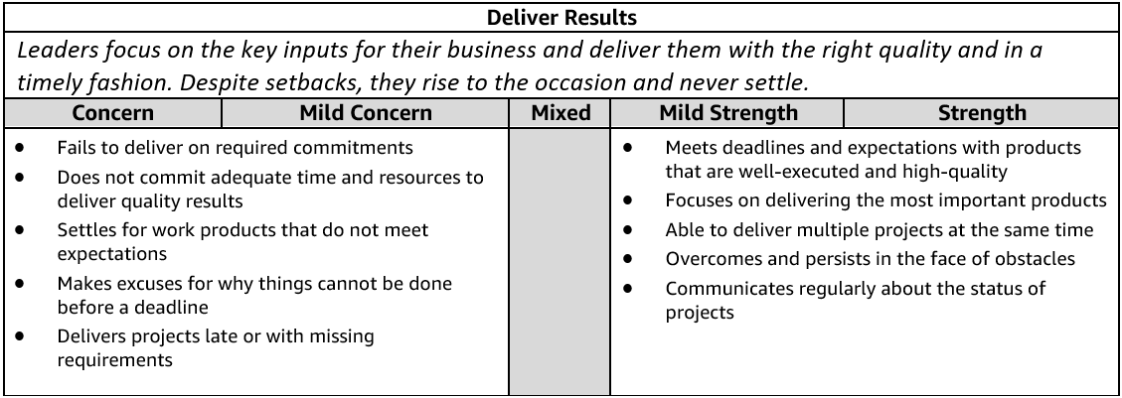

**Deliver Results - Suggested Behavioral Interview Questions**Please choose 2-3 questions below for your interview.

1. **Give me an example of a time when you were able to deliver an important project under a tight deadline**. What sacrifices did you have to make to meet the deadline? How did they impact the final deliverable? What was the final outcome?

**IQM**

**ABB WAS AWARDED THE REGIONS PRESTEGIOUS kaia PROJECT**

**To be delivered n 3 phases to be completed by 2035 TOTAL PROJECT BUDGET WAS WORTH OVER 7 BUSD = OVER 27 BSAR**

**Winning this project was an honor for ABB**

**ABB had to deliver 42 panels in a span of 6 months as part of the phase 1 of the project and each panel to have ALL ABB PARTS**

**Each panel had Customized combination of RELAYS, MCBS, CAPACITORS, TERMINAL BLOCKS, CONTACTORS BREAKERS ACBs ETC ALL ABB….**

**VERY TIGHT DEADLINES**

**first thing I did was, my TEAM was enthusiastic and asked them how each of them felt about the project and successfully DELIVERING this on time within budget…. It was under the direct eyes of the SrMgmt**

**Alligned with my TEAM …. daily update meetings started with the campaign KAIA ABB Success TEAM**

**I had to send in a daily short update to my MANAGER too.**

Feeder facotries, aligned them, manufacturing team for their production lines to be available on emergencies, with Shipping agents worked under tight schedule without affecting the other business related purchases.

Had to align the FF to block materials reserved for other geographies as SACE was the single supplier of Breakers catered to all geographies.

FFs were located at different time zones had to coordinate with them on their time zones….

My team and I worked extra hours sometimes on week ends to accomplish the task in additional to the needs of our regular customer too….

Worked with my manager to APPROVE them comp offs…..

PROJECT WAS SUCCESSFULLY DELIVERED ON TIME THE SIGN OFF WAS CELEBRATED …..

MORALE WAS HIGH AND ENTHUSIASTIC….

1. **Tell me about a time when you had significant, unanticipated obstacles to overcome in achieving a key goal.** What was the obstacle? Were you eventually successful? Knowing what you know now, is there anything you would have done differently?

**Capetown Connec**

HCLA I had 3 wks remaining to GO LIVE on an important CRM SAP integration project at CADBURY….when suddenly when two of my KEY onsite resourcs fell sick and I had to go live in 3 weeks come what may…CADBURY knew this as the resources were on site but there was no change in the GO LIVE SCHEDULE.

I reached out the Resourcing Manager, didn’t have any resource, no one on bench in the region…..

He found one in the UK time zone….I had to allign with several teams HR, security , Business line head to get him on board , security access,,,,etc

I played the role of a BA too giving him the KT of the project and bring him to speed to deliver it on time for which I had to work different time zones for 3 weeks and had the GO LIVE on TIME

Client was happy and signed off the project go live and also sent an appreciation note to my higer ups….

1. **Tell me about a time when you not only met a goal but considerably exceeded expectations.** How were you able to do it? What challenges did you have to overcome?

**IQM –** Goals highlight that

My assets are my viewpoint that I and my company exist because of my CUSTOMERs so my scope of delivery is PRODUCT plus….

I believe in my TEAM….. RESPONSIBILITY is always coupled with AUTHORITY….. I MAKE THEM OWN THE TASK

I don’t compromise on the Quality I deliver to the customer and the quantity of business expected by my company.

I deep dive into the PROBLEM….. a problem well defined is a problem half solved.

I belive in collaborating, Brainstorm for alternatives from my team and myself

1. **Tell me about a time when you or your team were more than half way to meeting a goal when you realized it may not be the right goal or may have unintended consequences.** What was the situation? What did you do? What was the outcome? Looking back, would you have done anything differently?
2. **Give me an example of a mission or goal you didn’t think was achievable.** What was it and how did you help your team try to achieve it?  Were you successful in the end? Looking back, would you have done anything differently?

Post peak party in a month

1. **Tell me about a time when you did not effectively manage your projects and something did not get completed on time.** What was the impact? What approaches do you use to make sure you are focusing on the right deliverables when you have several competing priorities?
2. **It can be difficult to set goals for a team that are challenging, yet achievable. Tell me about a time when you hit the right balance.** How did you approach setting the goals? What was the outcome? (Manager)

CADBURY ADAMS Canada SIEBEL integration PROJECT (6 weeks) I had to drive this project with teams from cross geographies and cross business line

2 onsite was from vendor reporting to different business line

6 offshore were from another vendor different time zones

Different wavelength band width as they were all parallelly working on other projects too as I was

I reapeatedly reinforced 2 things to myself and to my entire team….

1. the common GOAL we all agreed on as a TEAM to accomplish this project or task
2. update the status of the progress on a daily basis to each member

**IQM – More than 50% of the team were externally hired and no dedicated advisors as well so it was indeed challenging . So in normal circumstances 85% was achievable but in my area it was challenging ….then elaborate on the actual IQM doc.**

**DIVE DEEP**

**Definition and Indicators**

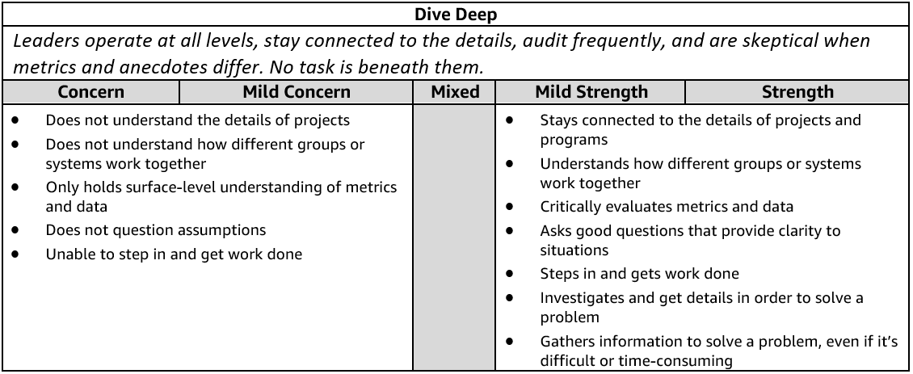

**Dive Deep - Suggested Behavioral Interview Questions**Please choose 2-3 questions below for your interview.

1. **Tell me about a time when you were trying to understand a complex problem on your team and you had to dig into the details to figure it out**. Who did you talk with or where did you have to look to find the most valuable information? How did you use that information to help solve the problem?
2. IQM
3. **Tell me about a situation that required you to dig deep to get to the root cause.** How did you know you were focusing on the right things? What was the outcome? Would you have done anything differently?
4. Connections Capetown
5. **Tell me about a problem you had to solve that required in-depth thought and analysis.** How did you know you were focusing on the right things? What was the outcome? Would you have done anything differently?
6. ABQ
7. **Walk me through a big problem or issue in your organization that you helped to solve.** How did you become aware of it? What information did you gather? What information was missing and how did you fill the gaps? Did you do a reflection at the conclusion of the project? If so, what did you learn?

**ABQ / Connections capetown**

**WARRANTY of SACE BREAKERS…….**

**Our terms with supplier : 1 year operational warranty from delivry date**

**Projects team TERMS with their customer : 1 year operational warranty from Commissioning date.**

1. **Tell me about a specific metric you have used to identify a need for a change in your department.** Did you create the metric or was it already available?  How did this and other information influence the change? What was the outcome of this change?

**INGENII –** Current focus is only completion , we decided that quality of manager intervention , frequency of the intervention …these were not there so this was designed and currently in pilot phase for all L5 managers.

**SAVINGS TARGET ON ALL LOCAL VENDOR POs….**

1. **Have you ever created a metric that helped identify a need for a change in your department?** What was the metric? Why did you create it? How did this and other information influence change? What was the outcome of the change?

INGENII COACHING QUALITY

**SAVINGS TARGET ON ALL LOCAL VENDOR POs….**

1. **Tell me about a time when you had to validate the assumptions underlying a direct report's project.** How did you decide follow up was necessary? What steps, if any, did you take to validate the assumptions? What was the result? (Manager)

**My DR was leading IQM for HYD NA teams and was not able to meet the goal .** So based on my interventions I was able to identify two major root causes , externally hired supervisors were not trained or confident about the skills they were managing , supervisors managing multiple skills upto 5 skills in a team causing impact. I identified and deployed actions (refer the doc for actions and impact)

**EARN TRUST**

**Definition and Indicators**

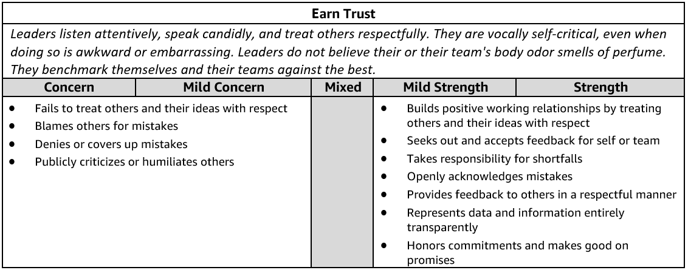

**Earn Trust - Suggested Behavioral Interview Questions**Please choose 2-3 questions below for your interview.

1. **Tell me about a time when you had to communicate a change in direction that you anticipated people would have concerns with**. What did you do to understand the concerns and mitigate them? Were there any changes you made along the way after hearing these concerns? How did you handle questions and/or resistance? Were you able to get people comfortable with the change?
2. Transport allowance ---

**ABB factory we were located about 25 kms away from the city, we had the hardship allowance paid out as a flat amount……**

**The Accounts dept came out with a rule that people had to submit the ccopies of their vehicle registration card to avail it. It was not a welcome idea for most of the employees…..**

**I reached out to theHR and spoke to them and they gave me a reason that the company auditors had this requirement with the accounts dept….**

**I simply explained this to the tteam working with me…**

1. **Give me an example of a tough or critical piece of feedback you received.** What was it and what did you do about it?

Feedback was given on collaboration on Post peak party -----

Coz of bias for action to be done in a span of 25 days and we had to close on multiple aspects of the party from managing vendors , engagement , venue . choreopgraphers , transport , wfm etcc…..post peak party wouldn’t be successful

I divided the responsibility among two of us and helped her take decisions on her own on the designated responsibilities ..she felt very empowered and engaged..

Eventually the post peak party was very successful and received positive feedback from peer as well as the other site leader…

One decision was made without consulting her and that made her feel less important resulting in escalation…..venue was suppose to be closed as there were dates which would hve been released …

**On successful completion of the prestigiour KAIA project My manager advised me to celebrate with the team .....**

**Out of sheer enthusiasm I searched for a GOOD venue and informed the team And I asked the dates….one of my key team member was off line and couldn’t be consulted to take this decision but it turned out to be bad feedback of not consulting the venue with that key player…**

**I immediately trashed the idea of the venue and gave the authority to 2 guys in the team including him…..-🡪 this made amends and as the team felt EMPOWERED all were happy doing their stuff for the party….**

1. **Describe a time when you needed to influence a peer who had a differing opinion about a shared goal.** What did you do? What was the outcome?

Peer wanted to explore different venues for post peak party and shared goal was to decide on post peak party venue…..

We had to make the post peak party happen in a short span of one month and if we invest more time in exploring the venues then we would hve invested the entire month in exploring….

Meeting was conducted along with all stake holders and the entire venue details along with cost and other competitors cost were shared and everyone got aligned to the JRC venue. Later I involved her in every decision and made her feel more empowered and engaged and even divided the responsibilities so she can take her own calls in certain areas .

**On successful completion of the prestigious makkah high speed rail project the local BU managers wanted to organize the party for all the TEAMS including the business teamd.**

**Out of sheer enthusiasm I searched for a GOOD venue and informed the team And I asked the dates….one of my key team member was off line and couldn’t be consulted to take this decision but it turned out to be bad feedback of not consulting the venue with that key player…**

**I immediately trashed the idea of the venue and gave the authority to 2 guys in the team including him…..-🡪 this made amends and as the team felt EMPOWERED all were happy doing their stuff for the party….**

1. **Give me an example of a time when you were not able to meet a commitment.** What was the commitment and what were the obstacles that prevented success? What was the impact to your customers/peers and what did you learn from it?

Pricing procedure ZPR_ Pack Price program –Customer Material infor record….

Cross funtinal projects 3 weeks duration..Tough timelines / mixed team from different specs diff time zones different vendors…..

1. **Tell me about a time when your team’s goals were out of alignment with another team you relied on in order to meet your goal.** How did you work with the other team? Were you able to achieve your goals?

ZNAC Program for the delivery point variance from customer master

Cross funtinal projects 4 weeks duration..Tough timelines / mixed team from different specs diff time zones different vendors…..

3 teams of 3 differenct platforms had to connect the feed into SAP….

1. **Tell me about a time when you uncovered a significant problem in your team.** What was it and how did you communicate it to your manager and other stakeholders? What did you do to address the problem? How did you manage the impact of this problem for the rest of your team?

Walk the store – short calls then checked the entire site and there were set of associates who had a trend on ….seller is talking ..u go on mute…n seller drops the call eventually……behavior issues…

1 month we ensured audits were done by supervisors ….associate were coached…mechanisms were brought into place to fix this issue across …

1. **Describe a time when you improved morale and productivity on your team**. What were the underlying problems and their causes? How did you prevent them from negatively impacting the team in the future?

**IQM -**-- Sups have been calling out multiple times that they are not able to handle multiple skills…. N their morale was going down as nobody was identifying their concerns and challenges…. So I acknowledged that it’s an issue to handle multiple skills and worked towards solving this for good.

1. **Tell me about a time when a team member was struggling to keep up or fit in and you stepped in to help out.** Why did you think they were struggling or not fitting in? Why did you decide in step in and support? What did you do to help out? How did it impact your work? What was the outcome? What did you learn from that situation?

**Sandeep Routray LE -** TT

1. **Tell me about a time when a team member was not performing well and impacted your work.** How did you handle that situation? Why were they not performing well? What was the outcome? What did you learn from that situation?

**Sandeep Routray LE -** TT

**FRUGALITY**

**Definition and Indicators**

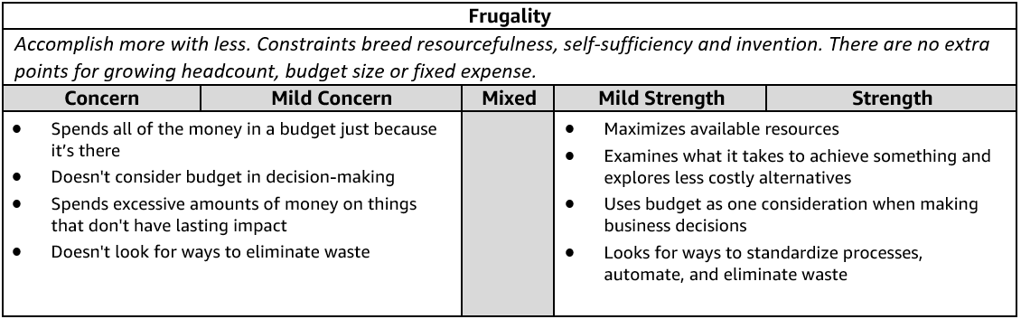

**Frugality - Suggested Behavioral Interview Questions**Please choose 2-3 questions below for your interview.

1. **Give me an example of how you have helped save costs or eliminate waste within your role or organization**. What was the situation? What was the impact?
2. **Describe a time when you had to get a project or initiative completed with limited resources.** How did you approach the situation? What was the impact? Knowing what you know now, would you have done anything differently?
3. **Tell me about a time when you didn’t have enough resources to do something you felt was important but found a creative way to get it done anyway.** What was the situation? What other options did you consider? How did you decide on a path forward? What was the outcome?
4. **Tell me about a time when you had to make tradeoffs between quality and cost.** How did you weigh the options?  What was the result? Would you have done anything differently?
5. **Tell me about a time when you generated a creative solution to a problem or project without requiring additional resources.** What was the problem?  What was the solution and how did you come up with it? What was the outcome?
6. **Give an example of a time you requested additional funding/budget to complete a project.** Why was it needed? Did you try to figure out another approach? Did you get the additional resources? Why or why not?
7. **Describe a time when you had to decide whether or not to award or ask for additional resources.** What criteria do you use for making the call? What was the outcome? Knowing what you know now, would you have done anything differently? (Manager)
8. **Give an example of a time when you challenged your team to come up with a more efficient solution or process.** What drove the request? How did you help? What were some of your biggest challenges? What were the end results? (Manager)

**HAVE BACKBONE; DISAGREE AND COMMIT**

**Definition and Indicators**

**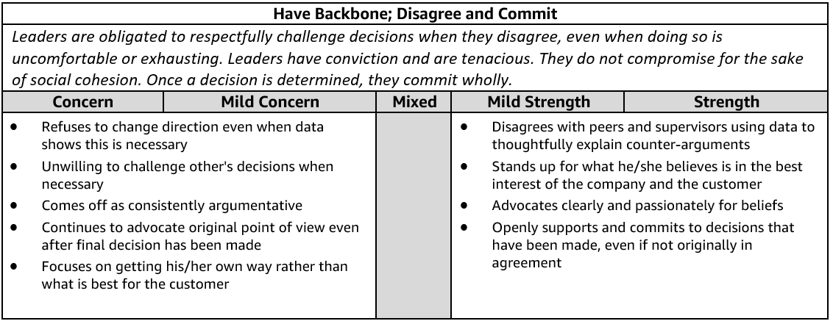  
Have a Backbone; Disagree and Commit - Suggested Behavioral Interview Questions**Please choose 2-3 questions below for your interview.

1. **Tell me about a time when you strongly disagreed with your manager or peer on something you considered very important to the business.** What was it and how did you handle it? Knowing what you know now, would you do anything differently?
2. **Describe a time when you took an unpopular stance in a meeting with peers and your leader**. What was it? Why did you feel strongly about it? What did you do? What was the outcome?
3. **Often, we must make decisions as a group. Give me an example of a time you committed to a group decision even though you disagreed.** What factors led you to commit to the decision? Would you make the same decision now?
4. **Describe a time when you felt really strongly about something on a project but the team decided to go in a different direction.**How hard did you press the issue? How did you approach that project afterward?
5. **Tell me about a time when you pushed back against a decision that negatively impacted your team.** What was the issue? How did it turn out? Would you have done anything differently?
6. **Give me an example of when you submitted a great idea to your manager and they did not support it.** What was the idea? How did you handle the lack of support?
7. **Describe a time when you had to support a business initiative that you didn't agree with**. How did you handle it? How did you deliver the message to your team?
8. **Tell me about a time when the business gained something because you persisted for a length of time**. Why were you so determined? How did it turn out?

**HIRE AND DEVELOP THE BEST  
Definition and Indicators**

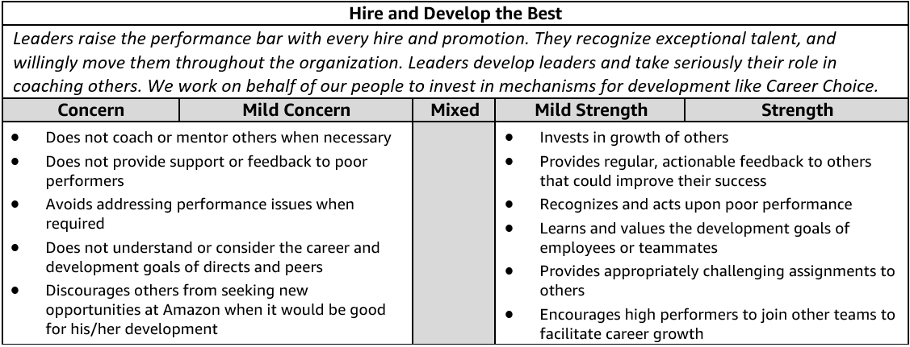

**Hire and Develop the Best - Suggested Behavioral Interview Questions**Please choose 2-3 questions below for your interview.

1. **Tell me about a time when you helped one of your team members develop their career**. How did you help that team member? What was the result?

**Sandeep Routray –** LE To TT

1. **Tell me about a time when you invested in an employee's development.** What did you invest in and why? What was the outcome? Can you share an example where investing in an employee's development didn't work out?

I only invest into people when I am confident about their core skills and every time I invested it has always worked out…. I have put people on plan and they improved and performed … Krishna & Rajan

1. **Give me an example of a time you provided feedback to develop the strengths of someone on your team**. Were you able to positively impact their performance?

Sandeep Routray

1. **Tell me about a time when you provided coaching for a team member.** What started the coaching? What was the outcome?

Sandeep Routray and Zahid Khan

1. **Tell me about someone you hired that you thought complemented your skills.** How did you coach an individual in areas where you have a weakness? (Manager)
2. **Tell me about a time when you helped a remote team member develop their career.** Can you give me an example of a specific team member and how you helped them develop across the geographic distance? (Manager) –

not relevant…if we consider VCC then it is sandeep who is again from the same city.

1. **Describe a person who struggled to get promoted under your leadership and how you helped facilitate their success.** (Manager)

**Rajan Bhagat----**

1. **Tell me about your most challenging talent review and promotion process that you conducted for your team**. What made it challenging? What factors did you consider in your talent review? What factors did you consider in the promotion process? Did you incorporate a tool to counter unconscious bias? If yes, how? How do you manage perceptions of unfair treatment? What did you learn from this process? Knowing what you know now, would you have done anything different?(Manager)

**Talent review** ---was challenging….as we cannot lower the bar to meet the bell curve….when the person is already on plan and has not shown any siginificant improvement. (bhushan H 1 example)

1. **Describe a time when you constructed a team to accomplish a goal.** What factors did you consider in constructing the team? Did you factor diversity into your team construction? How did you balance work requirements, team skill composition, and team stretch opportunities? What do you consider when you allocate work? How did you ensure team members were able to work effectively together?  Would you have done anything differently? (Manager)

**Post peak party**

1. **Tell me about a time when you had a low performing individual on your team.** How did you deliver feedback? Did their performance improve? (Manager)

**Sandeep Routray**

**INSIST ON THE HIGHEST STANDARDS**

**Definition and Indicators**

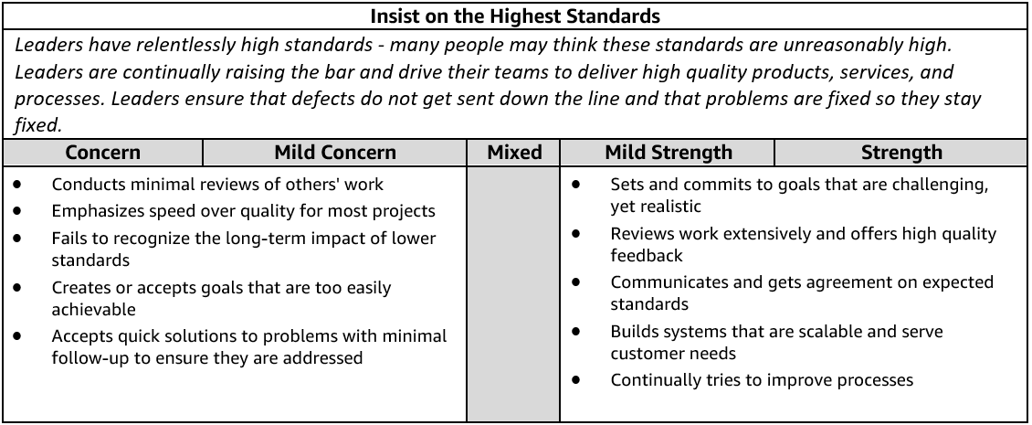

**Insist on the Highest Standards - Suggested Behavioral Interview Questions**Please choose 2-3 questions below for your interview.

1. **Describe a time when you refused to compromise your standards around quality/customer service, etc**. Who was your customer? What was the result?
2. **Tell me about a time when you were unsatisfied with the status quo**. What did you do to change it?  What was the impact? Would you do anything differently in the future?
3. **Tell me about a time when you worked to improve the quality of a product / service / solution that was already getting good customer feedback.** Why did you think it needed improvement? How did customers react?
4. **Tell me about a time when you had to make a decision between standards and delivery.** What tradeoffs did you have make? What was the outcome? Knowing what you know now, would you have done anything differently?
5. **Give me an example of a goal you’ve had where you wish you had done better.** What was the goal? How could you have improved on it?
6. **Describe the most significant continuous improvement project that you led.** What was the catalyst to this change and how did you go about it? What was the outcome?
7. **Tell me about a time when you used feedback about your team to drive a change.** How did you gather or receive feedback on your team's performance? What was the outcome? (Manager)

**INVENT AND SIMPLIFY**

**Definition and Indicators**

**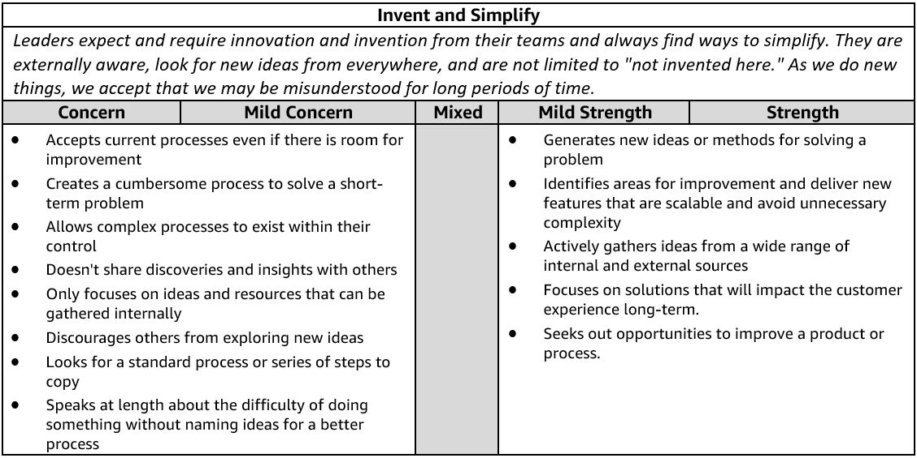  
Invent and Simplify - Suggested Behavioral Interview Questions**Please choose 2-3 questions below for your interview.

1. **Give me an example of a complex problem you solved with a simple solution. What made the problem complex?** How do you know your solution addressed the problem?
2. **Describe the most innovative thing you’ve done and why you thought it was innovative.** Ask for one or two more examples to see if it's a pattern of innovative thinking. What was the problem it was solving? What was innovative about it?
3. **Tell me about a time when you were able to make something simpler for customers**. What drove you to implement this change? What was the impact?
4. **Describe a time when you influenced and drove new thinking and innovation out of your team.** Give an example of how your approach led to a specific innovation.
5. **Tell me about a time when you had a challenging problem or situation that the usual approach wouldn't address.** How did you select an alternative approach? What alternative approach(es) did you consider? What was the end result? What was the impact?
6. **Tell me about a novel idea you had or decision you made that had a big impact on your business.** What was novel about it?
7. **Tell me about a time when you enabled your team/a team member to implement a significant change or improvement.** What problem were you trying to solve? How did you measure success? What was the end result/impact? (Manager)

**Learn and Be Curious**

**Definition and Indicators**

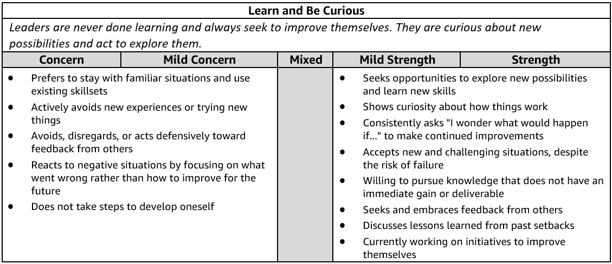

**Learn and Be Curious - Suggested Behavioral Interview Questions**Please choose 2-3 questions below for your interview.

1. **Tell me about a time when you realized you needed a deeper level of subject matter expertise to do your job well.** Whatdid you do about it? What was the outcome? Is there anything you would have done differently?
2. **Describe a time when you took on work outside of your comfort area.** How did you identify what you needed to learn to be successful? How did you go about building expertise to meet your goal? Did you meet your goal?
3. **Tell me about a time when you didn’t know what to do next or how to solve a challenging problem.**How do you learn what you don't know? What were the options you considered? How did you decide the best path forward? What was the outcome?
4. **We all have things about ourselves we'd like to improve on at work. Give me an example of something that you've worked on to improve your overall work effectiveness.** What resources did you identify to help you develop? What was the impact?
5. **Give me an example of a time when you explored a new or unexpected area of an existing space.**Why hadn't this been explored already? Why did you move forward? What were the results or what was the impact?
6. **Describe a time when someone on your team challenged you to think differently about a problem.** What was the situation? How did you respond? What was the outcome?
7. **Tell me about a time when you used external trends to improve your own company's products or services.** How did you keep up to date with external trends? How did you decide to apply them to your own company? What was the result?

**OWNERSHIP**

**Definition and Indicators**

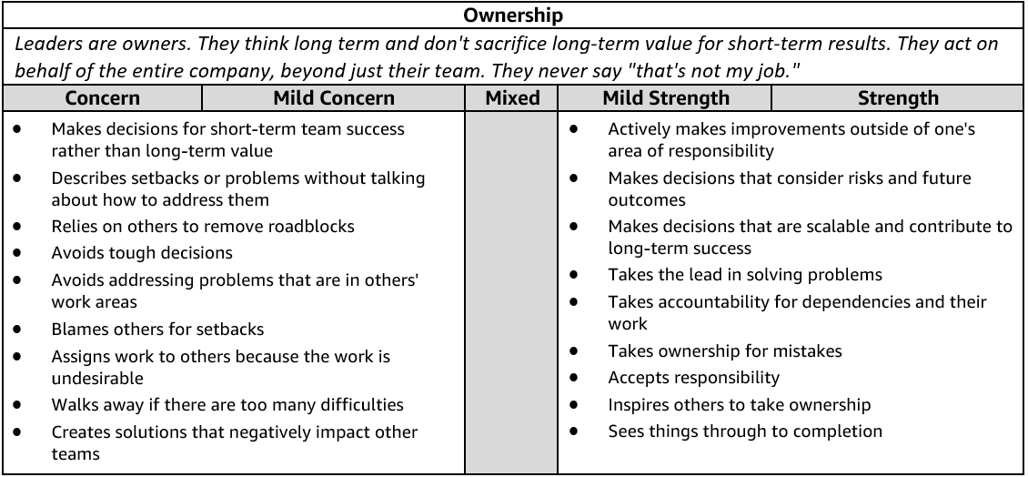

**Ownership - Suggested Behavioral Interview Questions**Please choose 2-3 questions below for your interview.

1. **Tell me about a time when you took on something significant outside your area of responsibility.** Why was it important?  What was the outcome?
2. **Describe a time when you didn't think you were going to meet a commitment you promised.** How did you identify the risk and communicate it to stakeholders? Is there anything you would do differently?
3. **Give me an example of an initiative you undertook because you saw that it could benefit the whole company or your customers, but wasn’t within any group’s individual responsibility so nothing was being done.**
4. **Tell me about a time when you made a hard decision to sacrifice short term gain for something that would create long term value for the business**. What was the outcome? Knowing what you know now, would you have done anything differently?
5. **Describe a time when you had to transition a project you owned to a new owner.** What steps did you take to make sure the transition went smoothly? Tell me about a time that you chose to get involved in a project that you had already transitioned to somebody else. What was the situation? Why was it important to get involved?
6. **Tell me about a time when you saw a peer struggling and decided to step in and help.** What was the situation? Why did you decide to step in? What actions did you take?

**THINK BIG**

**Definition and Indicators**

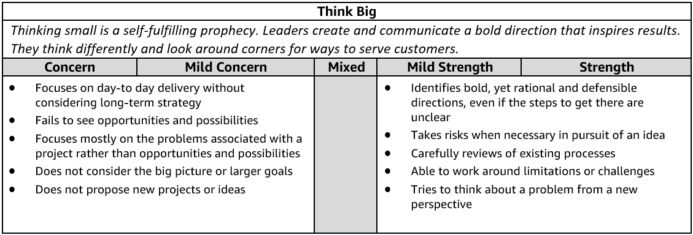

**Think Big - Suggested Behavioral Interview Questions**Please choose 2-3 questions below for your interview.

1. **Tell me about time when you were working on an initiative or goal and saw an opportunity to do something much bigger or better than the initial focus.**Did you take that opportunity? Why or why not? What was the outcome?
2. **Give me an example of how you have changed the direction or view of a specific function/department and helped them embrace a new way of thinking.** Why was a change needed?  What was the outcome?
3. **Give me an example of a time you proposed a novel approach to a problem.** What was the problem and why did it require a novel approach? Was your approach successful?
4. **Tell me about a time when you drove adoption for your vision/ideas.** How did you know your vision/idea was adopted by others? How did you drive adoption for your vision/ideas? How did you track adoption? Would you do anything differently?
5. **Give me an example of an idea or vision you had which was adopted by global stakeholders.** How did you drive adoption for your vision/ideas? How did you track adoption? Would you do anything differently?
6. **Tell me about a time when you thought differently to improve a process that was working.** What assumptions did you have to question? How did you evaluate if the change improved the process? Knowing what you know now, would you do anything differently?
7. **Tell me about a time when you encouraged a team member or organization to take a big risk.** How did you balance the risk against existing business goals? What was the outcome? What did you learn from this situation?(Manager)
8. **Tell me about a time when you established a vision for a (team, product, initiative) when there wasn't one.** How did you gain buy-in and drive execution? What was the outcome? Would you have done anything differently? (Manager)

**STAR WORKSHEET**

Your Behavioral Question: __________________________________________________________________ Leadership Principle: ______________________________________

* Choose behavioral question that provoke specific examples or stories for your assigned Leadership Principle(s).
* Process the example using STAR. Stories have beginnings (Situation/Task), middle (Actions) and ends (Results).
* Once you have established the story, PROBE to dive deeper on your assigned competency (Leadership Principle), get clarity or pursue a concern.
* If appropriate, CHALLENGE the candidate’s statements, decisions or thought process.

|  |  |  |
| --- | --- | --- |
| **S**  **T** | **SITUATION/TASK - Describe the situation/task you faced and the context of the story** Answers the questions: **where** did this occur, **when** did it happen, **why** is it important?  **Probing Questions:**   * Why is this important? What was the goal? * What was the initial scope of the project? What were the challenges? * What were the risks and potential consequences if nothing happened?   **Challenge Questions:**   * Why did you choose this story to illustrate a xyz accomplishment? * What other stories can you think of that demonstrate…xyz? * Could you come up with an example that is more recent? | **Notes** |
| **A** | **ACTION - What actions did you take?**  Answers the questions: **what** did you personally own, **how** did you do it, **who** else was involved?  **Probing Questions:**   * **Deep probe functional expertise and/or assigned core competency.** * Were you the key driver or project owner? * What was your biggest contribution? What unique value did you bring? * What were the most significant obstacles you faced? How did you overcome them?   **Challenge Questions:**   * What did you do specifically versus the team? * How did you set priorities…deal with xyz problem… or get manager buy-in? * What decisions did you challenge? Why? How did you influence the right outcome? |  |
| **R** | **RESULTS - How did you measure success for this project? What results did you achieve?**  **$** Cost savings, revenue generation  **#**  Quantify to understand volume, size, scale  **%** Percentage change, year over year improvements  **🕝** Time to market, implementation time, time savings  **☺** Impact on the customer, the team  **δ** Quality improvements  **Probing Questions:**   * Why did you choose to focus on these results? What other results were important? * You mentioned revenue, what percentage change is that year over year? * What trade-offs did you have to make to achieve this? (quality, cost, time) * I’m concerned about…(the time it took, the volume, the customer impact), tell me more…   **Challenge Questions:**   * What were the lessons learned? What would you have done differently? * How would you implement this at Amazon? * How did these results compare to your actual goals? (refer back to goal stated in Situation) |  |